ITEM SIX
SECTION A:

- Find the product of 28 and 4. | - If p = q, q = 2 and r = 4  work out: q ^{r} + p
- Write 2009 in words. | - What is the value of 1 – 8?
- What is the complement of 67⁰? | - Find the next number in the sequence: 0, 3, 1, 4, 2, _______.
7. Given that set M = { 2, 5, 8} and set N = { 6, 9}, find M ∩ N. | 8. Calculate the square root of 0.25.
9. Sarah slept for 2 hours and 15 minutes. At what time did she wake up if she went to bed at 8.30 p.m.? | 10. Using a pair of compasses, a pencil and a ruler only, bisect the line below.  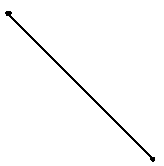
11. If 4 plates cost sh.24,000, how much will 8 such plates cost at the same rate? | 12. Solve: 5x – (x + 4) = 4.
13. Kato scored the following marks in a game: 4, 6, 2, 4, 6, 4 and 0. Find his modal mark. | 14. OJAMBO bought a watch at sh. 15000 and sold it at a loss of 20%. At what price did he sell the watch?
15. Write XCIV in Hindu Arabic numerals.  18. The bearing of town P from town Q is 060⁰. What is the bearing of town Q from town P? | 16. OUMA had 40 Km to cover after travelling ³/₅ of the journey. How long was the journey?  17. Find the area of the shaded part of the circle.  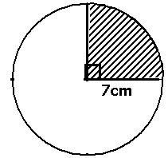
19. Change 10010_{two} to base 10. | 20. How many lines of symmetry does the figure below have?  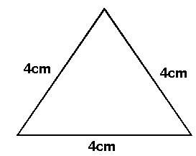

Section B

21. In a class of 56 pupils, 25 like Science (S), 30 like Mathematics (M) x like both subjects and 2 like neither of the subjects.  a. Draw a venn diagram  b. Find the value of x  (c) How many pupils like Science only? | 22. The figure below is a rectangle. Study it and answer the questions that follow.  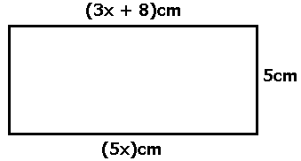  - Find the value of X.  - Calculate its area.  - Work out its perimeter.
23(a) What number has been expanded to give:
(8 x 10⁵) + (6 x 10⁴) + ( 3 x 10²) + (4 x 10¹)?

(b) Express 13000 in Scientific notation.

24. BWIRE wrote three digit numbers using the following digits: 6, 7, and 9 without repeating any of the digits in each number.  - Write down the possible three numbers.  (b) What is the sum of the least and greatest number  written?  - What is the probability of BWIRE writing a number bigger than 600? | 25(a) A man put sh.120,000 in a savings society which gives a simple interest of 5% per year. Find the total amount he had with the savings society after 4 months.  (b) A trader has a bundle of ten thousand shilling notes number consecutively from AM8964167 to AM8964266. How much money does the trader have?
26. A BUS rode North from town A for a distance of 40 Km to town B, then he rode to the west for 30 Km to town C.  (a) Draw an accurate diagram to show her journey using a scale of 1cm = 10Km.  (b) Find the shortest distance between town C and  town A. | 27. A lady went shopping with a sh.50,000 note and bought the following items:  2 ½ Kg. of meat at sh.8000 per Kg.  2 Kg. of posho at sh.2000 per Kg.  3 Kg. of irish potatoes at sh.1500 per Kg.  500 gm. of sugar at sh.3200 per Kg.  - What was her total expenditure?  - How much money did she remain with?
28. Given that y = x – 1, complete the table below. | 29(a) Solve: 7m + 4 = 3m + 20  - Simplify: (5p – 4q) – (4q – 5p)
  x | ……….. | 0 | ………. | 7
  y | 2 | ………. | 4 | 6
30. In a class of 48 pupils, ¾ like Maths, 2/3 of the remainder like English and the rest like SST. How many pupils like SST? | 31. Convert 54k.p.h to m/s.
32. The pie chart below represents Taabu’s expenditure for the month of June. Use it to answer the questions that follow.  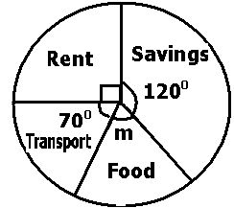 | - Find the value of m.  - If he spent sh.72,000 on rent, how much money did he earn that month?  - How much more money did he spend on savings than on transport?
ITEM TWO

SECTION A:(40 marks)
1. Subtract: 2 1 0 – 2 1 =
2. Round off 3865.8 to the nearest hundreds.
3. In the diagram below, calculate the value of n in degrees.
4. Add: 1 + 2
- 5
5. A text book weighs 870 grammes. Express the weight of the book in kilograms.
6. Write 70,080 in words.
7. A die is tossed once, what is the probability that a number less than 5 shows up?
8. Work out: ¯3 + +5 + ¯4
9. A baby was born at a quarter past mid-night. Express this time on a 12 hour clock system.
10. Drop a perpendicular line from A to meet line XY.
A
.

X_______________Y

11. Work out: 1101two – 111two
12. 9 boys take 10 days to slash a school compound. How many more boys are needed to slash the school compound in only 6 days working at the same rate?

13. Simplify: 4p – 3p2 – 3p + 4p2 + 5
14. Given that A = {a,b,c,d,e,f,g} and B = {a,e,I ,o,u}. Find (A ∩ B)¹
15. A radio costs Kshs. 4000. Find the cost of the radio in Uganda shillings if Ksh. 1 cost Ugshs. 28.
16. Calculate the interior angle sum of a regular polygon whose interior angle measures 135º.
17. Find the lowest common factor of 12 and 16.
18. A set has 32 subsets. How many elements are in the set?
19. Solve for y : y + 4 = 9
3
20. Calculate the area of the semi-circle below.

Section B
- In a class, 13 pupils like English (E) only.t like both Maths(M) and English,(15 + t) like Maths but not English while 2 like neither of the two subjects.
- Complete the Venn diagram below using the above information.
ع=……..
n(M) = ……
n(E) = ……
t
2
……..
……..

- If 35 pupils like one subject only, find the value of t. (2mrks)
- Find a chance of picking randomly a pupil who likes maths . (2 mrks)
22. The table below shows the number of notes withdrawn from the bank in different denominations. Complete the table.

DENOMINAITON | NUMBER OF NOTES | AMOUNT
Shs. 1,000 | 25 | Shs. 25,000
Shs. 5,000 | 12 | Shs. ________________
Shs. ______________ | 30 | Shs. 60,000
Shs. 20,000 | ____________ | Shs. _________________
Shs. 50,000 | 8 | Shs. _________________
TOTAL AMOUNT |  | Shs. _________________

23. Lorna is 20 years youngest than Juma. In 15 years’ time, Juma’s age will be twice the age of Lorna. How old is Lorna?
24. The Highest Common Factors (HCF) of two numbers is 10 and their lowest common multiple (LCM) is 120. If one of the numbers is 40, find the other number?
25. The average of 5 girls is 21 years. If the age of one of them is 8 years, calculate the average age of the remaining girls.
26. The triangle ABC below is an Isosceles triangle. Study it and answer questions that follow.
a). Find the value of n in degrees.
b). Work out the size of angle ACB.
27. A tank is 5/6 full of water. When 800 litres is removed, the tank becomes 2/3 full. Calculate the capacity of the tank.

- The figure below is an isosceles triangle. Use it to answer the questions that follow.
8cm
(2y + 1)cm
(3y - 1)cm
h

- Find the value if y. (2 mrks
- Find the height (h) of the triangle. (3 mrks
- Calculate its area. (1 mrk)
29. A trader bought a suit at Shs. 100,000 and sold it at Shs. 80,000.
a). Calculate his percentage loss.
b). How much should he have sold the suit in order to realize a profit of 15%?
30. With help of a ruler, pencil and a pair of compasses only, construct a rhombus PQRS where PQ = 5cm and angle SPQ = 60º.

Measure;
a). length of diagonal QS.
b). Angle QSR.
31. A taxi driver covered a distance of 144km in 2 hours.
a). Calculate his average speed in km/hr.
b). Express the speed in metres per second.
32. Use the grid below to answer questions that follow.

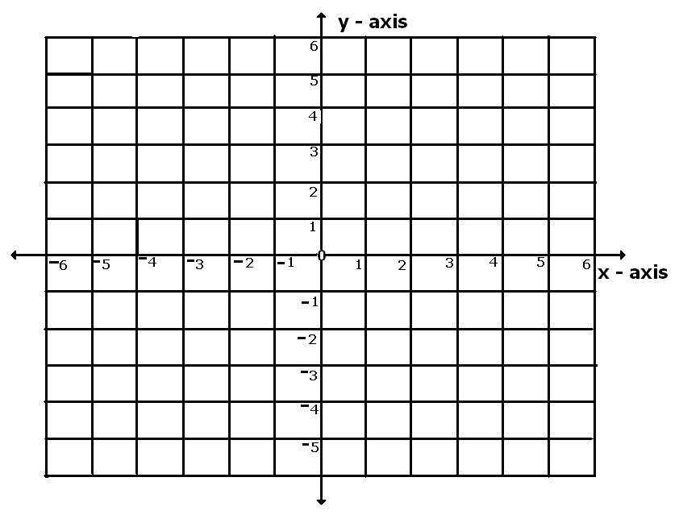

a). Plot the points A(¯2 , 1) , B(¯2 , ¯2) , C(2 , ¯2) , D(2 , 2)
b). Join the points and name the polygon formed.

END

ITEM THREE
SECTION A:(40 marks)
1. Work out: 303
x 4

2. Simplify: 2x + 3y + x + 4y

3. Write 2012 in words.

4. Subtract: 101_{two}
- 11_{two}

5. Describe the shaded part in the Venn diagram below.

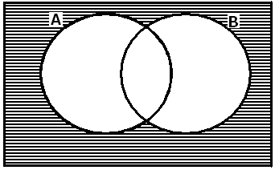

6. Find the number whose standard form is 5.2 x 10².
7. Express 0.2727… as a common fraction in its simplest form.
8. Find the next number in the given sequence: 1, 3, 9, 27, _____________.
9. Write 12:30 a.m. in the 24-hour clock.
10. Solve for x: 3 – 4 = x (finite 5)
11. Using a pencil and a pair of compasses, bisect the given line below.

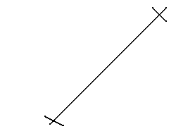

12. Nakiguli walked 0.5km. What distance did she cover in metres.
13. The mean of 4, 5, 0, x and 7 is 5, Find the value of x.
14. The cost of buying 400 Kenya shillings is Uganda sh.8000. How many Kenya shillings can Uganda sh.24,000 buy?
15. In the diagram below, there are vertically opposite angles. Calculate the value of angle p.

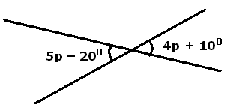

16. The bearing of Entebbe from Kampala is 045⁰. What is the bearing of Kampala from Entebbe?
17. Round off 43.392 to the nearest tenths.
18. The area of a square chalkboard is 100cm2. Find the length of one of its sides.
19. The probability that Dan will pass a Mathematics Mock exam ²/₉. What is the probability that Dan will fail this paper?
20. The temperature of a day rose from ¯5⁰ to 25⁰. What was the rise in the temperature?

SECTION B:

21. The size of each interior angle of a regular polygon is 144⁰.
(a) Find the size of each exterior angle.
(b) How many sides does the polygon have?
(c) What is the interior angle sum of the above regular polygon?

22. In a Mathematics test given to a class, the marks scored, frequency and total marks are shown in the table below.

Marks scored | Frequency | Total Marks
4 | 4 | 16
…………………… | 9 | 45
6 | ……………………. | 84
7 | 8 | …………………………….
8 | 5 | 40

(a) Complete the table above.
(b) What was the modal mark?
(c) How many pupils were in the class?
(d) What was the average mark scored?
23. In a P. 7 class, 60 girls like netball (N), 35 girls like volleyball (V) only and 20 girls like both games while 5 girls like neither of the two games.
(a) Represent the above information on the Venn diagram given below.
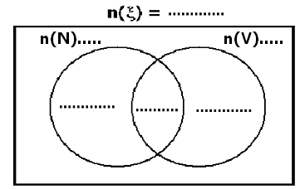

(b) How many girls are there altogether in the P. 7 class?
(c) If one girl is selected at random, what is the probability of selecting a girl who who likes only one game?
24. The diagram below shows a sports field of length 100m with semicircular ends of diameter 70m.
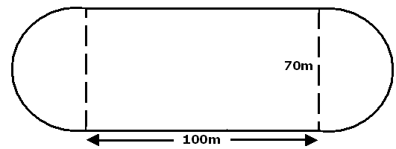

(a) Calculate the distance in metres a runner covers by running around the sports field.
(b) Find the area of the sports field.
25. Using a pencil, a ruler and a pair of compasses only, construct a regular hexagon od radius 4cm.
26. Patrick left town K and travelled 16km westwards to town P. He then travelled 12Km northwards to town R.
(a) Draw a sketch to show Patrick’s movements.
(b) Using a scale of 1cm to represent 4Km, draw an accurate diagram showing Patrick’s journey.
(c) From your diagram, find the shortest distance from town R to town K.

27. At Merryland Primary School, the price of uniform is as follows:
a shirt sh.5,000
a pair of shorts sh.10,000
a blouse sh.7,500
a skirt sh.12,500

A parent has 3 sons and 2 daughters in the school, how much money did he pay for full uniform for all his children?
28. The table below shows a train journey from Tororo to Lira.

UGANDA RAILWAYS
DISTANCE IN KM FROM TORORO | STATION | DEPARTURE TIME | ARRIVAL TIME
0 | Tororo | 0800 hrs | ……………………
56 | Mbale | 0945 hrs | 0900 hrs
120 | Kumi | 1120 hrs | 1100 hrs
160 | Soroti | 1410 hrs | 1300 hrs
270 | Lira | 1850 hrs | 1800 hrs

(a) What is the arrival time in Lira on the 12-hour clock.
(b) Wnhat is the distance in kilometres from Kumi to Lira?
(c) For how long did the train stop at Kumi?
(d) Find the average speed of the train for the whole journey.
29. In a meeting of head teachers of primary schools, the ratio of male headteachers to that of female haedteachers was 3:5 respectively. If there were 300 female headteachers in the meeting:
(a) How many male headteachers were in the meeting?
(b) Find the total number ofheadteachers who attended the meeting.
30(a) In an interview 2 marks are deducted for every wrong answer and 3 marks are awarded for every correct answer. What is the score mark for a candidate who gives 13 correct answers and 7 wrong ones?
(b) Use the clock face to work out 2 – 3 (finite 5)

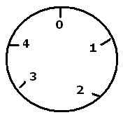

31. Wycliffe read ¼ of the pages of a book on Friday, a ¹/₃ on Saturday and the 30 remaining pages on Sunday. How many pages did Wycliffe read altogether?
32. On the grid below:

(a) Plot points: A(¯2,2), B(1,3), C(4,¯2) and D (¯2,2)
(b) Join A to B, B to C, C to D and D to A. Name the polygon formed.
(c) Find the area of the polygon formed in square units.
END
ITEM FOUR
SECTION A :( 40 marks)
1. Work out: 3
x 3

2. If a = 7, find the value of a² + a.
3. Set A = { Kato, Oloka, Nambi, Namboozo} and
B = { Owinja, Olayo, Kantono, Namboozo}. Find A ∩ B.
4. Write “Eighty thousand eight” in figures.
5. Factorize completely: 2xy – 4x.
6. What integers are represented by the arrow on the number line.
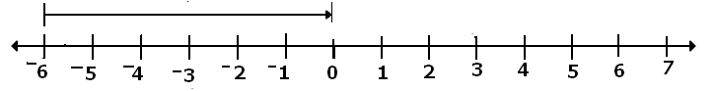

7. Given that represents 15 eggs and a tray carries 30 eggs, find the number of

trays obtained from the eggs represented by:

8. The figure below is made up of 2n small semicircles and one big semi circle. Find the perimeter of the figure.

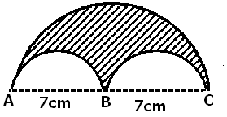9. Express sh.400 as a percentage of sh.1600.
10. Find the next Roman numeral in the sequence below:
I, II, III, Iv, V, VI, VII, VIII, _______.
11. Drop a perpendicular from point A to meet line CD at point M
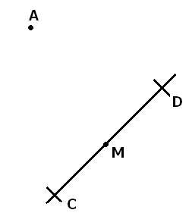

12. A 50 minute lesson ended at 11:00 a.m. At what time did it start?
13. Represent 1010_{two} on the abacus.
14. Work out the square root of: 11
25
15. Work out 9 + 892 + 99.
16. From the grid below, give the coordinates of K.

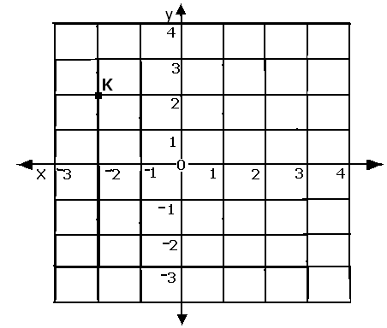

17. The ratio of red pens to blue pens in a box is 2:3 respectively. How many red pens are in the box if the of blue pens is 15?
18. Find fractional equivalent of 0.7272… in its lowest terms.
19. The line graph below shows Katongole’s performance in Term I exams. What was Katongole’s lowest mark?

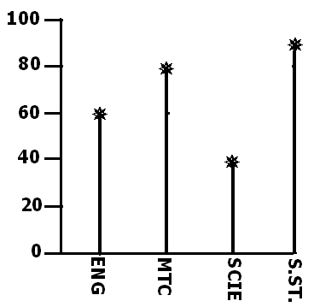

20. Binojjo deposited sh.150,000 in a bank that offers a simple interest rate of 4% p.a. How much was Binojjo’s interest after a period of 8 months?
SECTION B:

21(a) At a birthday party, children were given two queen cakes each, adults were served with 3 meat pies and each member who attended was served with a bottle of soda. If 48 queen cakes and 72 meat pies were served, how many bottles of soda were served?
(b) If a crate of soda contains 24 bottles, how many crates of soda were served at the party?
22(a) Study the figure below and find the value of y.
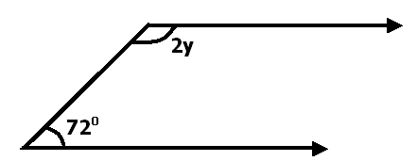

(b) The complement of 2x – 10⁰ is 50⁰. Find the value of x.
23. In a family of 19 members, 6 eat meat (M), 4 eat both meat and fish while y eat fish (F).
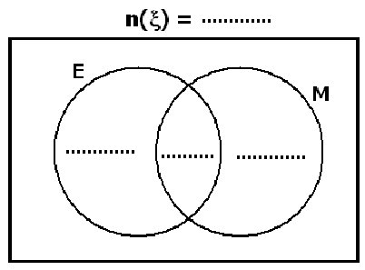(a) Represent the above information on the Venn diagram given below.

(b) How many members eat fish?
24. Two bells are rung at intervals of 40 minutes and 50 minutes for the lower and upper primary respectively.

(a) after how many minutes will the two bells ring together?
(b) If they last rung together at 8:00 a.m., at what time will they ring together again?
25(a) Simplify: 4 + 1 x 3 – 1 of 2
5 3 5 4 3

(b) Work out: 0.72 x 1.8
0.9 x 2.4
26(a) In a test, 3 pupils scored 50 marks each, 2 scored 60 marks each, 4 pupils scored 80 marks each and 1 pupil scored 90. Find the average mark of all the pupils.
27(a) Work out: (88 x4) – (48 x 4).
(b) Write 0.0072 in scientific form.
(c) Round off the smallest three-digit number formed by the digits 2, 6, and 5 to the nearest tens.
28. OKUKU drove at 35km/h for 2 hours from town A to town B. He then continued to town C at a speed of 40km/h for 3 hours. Calculate his average speed for the whole journey.
29. The pie chart below shows how mr. Don spends his monthly salary of sh.720,000.
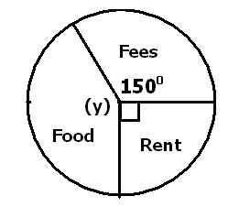

(a) Find the value of y.
(b) How much does spend on rent per month?
(c) How much less does Don spend on food than fees?
30. A book costs sh.(x – 300) and a pen costs sh.(x + 100). If Ndagire paid sh.2100 for 3 books and 2 pens:

(a) Find the value of x.
(b) How much did she pay for all the books?
31. Okello went shopping and bought the following items:
4 kg of rice at sh.1800 per kg.
3 kg of posh for sh.1300 each.
500g of onions at sh.2000 per 250g.
A bunch of matooke for sh.9000.

(a) Work out his total expenditure.
(b) If Okello was offered a discount of 10%, how much did he pay?
32(a) With the help of a ruler, sharp pencil and a pair of compasses only, construct triangle ABC in which angle ABC = 60⁰, BC = 7cm and angle BAC = 90⁰. Drop a perpendicular from A to meet BC at X.

(b) Measure AX.
END

ITEM FIVE
SECTION A:(40 marks)
1. Add: 78 + 438
2. Solve for y: 3y – 4 = 5
3. Calculate the area of the shaded part in the figure below.
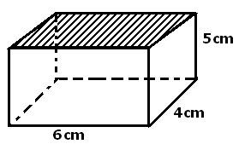

4. Write 30,106 in words.
5. Convert 113_{four} in decimal system.
6. How many ½ litre bottles of milk can be contained in a 5 litrejerrycan of milk?
7. using a ruler and a pair of compasses only, draw a perpendicular from P to meet AB at O.

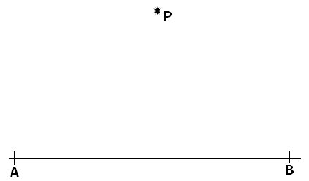

8. Describe the shaded region in the Venn diagram below.
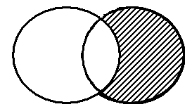

9. Simplify: ¯6 + ¯4 =
10. Tamale scored the following marks in Mathematics tests: 60, 78, 75, 78, 81. What was his modal mark?
11. Simplify ²/₃ – ¼.
12. Find the next number in the sequence: 1, 3, 6, 10, 15, _____.
13. Using a ruler and a pair of compasses only, construct an angle of 30⁰ in the space provided below.
14. Expand 4023 using exponents.
15. The exchange rate in the Bank of Uganda is Uganda sh.2300 to one United States Dollar (US $) How much money in Uganda shillings is equivalent to 17 US $?
16. Given that set A = {a, b, c, d, e} and set B= {b, c, e, g, h}. Find n(A∩B)
17. The distance from Masaka to Mbarara is 120 km. If it takes a Gaso bus 2 ½ hours to cover that distance, calculate its speed.
18. Write CXCLX in Hindu Arabic numerals.
19. Work out 2 ÷ 3 = ___________ (mod 5)
20. Factorize completely: (6y² – 2y)
SECTION B:

21(a) Peter and James shared sh.2000 in the ratio 2:3 respectively. How much more did James get than Peter?
(b) Simplify: 36 + 12 ÷ ( 4 x 3 )
100 100 10 10
22. Kato walked from his home to school at a speed of 30 metres per minute. If he took 1 hour to walk from his home to school, calculate the distance between his home and school in kilometres.
23. In a class, 40 pupils every pupil participates in Scouting (S). Some pupils participate in other activities such Games (G) and Debating (D) as shown in the Venn diagram below. Study it very carefully and answer the questions that follow.
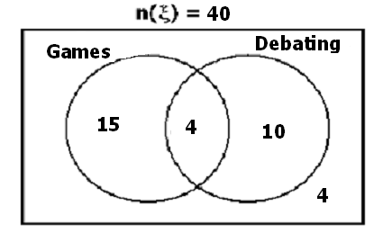

(a) How many pupils participated in only one activity?
(b) How many pupils participated in only two types of activities?
24. Mr. Mutyaba went shopping at the market and bought the items below:
2 kg of sugar at sh.2700 per kg.
3 kg of rice at sh.3200 per kg.
½ kg of maize flour at sh.1800 per kg.
2 bars of soap at sh.9000.
(a) What is Mr. Mutyaba’s total expenditure?
(b) If he was given sh.5100 as his balance, how much money did have at first?
25(a) Using a pencil, a ruler and a pair of compasses only, draw line BC = 8cm. Construct an angle ABC = 600 at point B with line AB = 5cm. Construct an angle BCD = 1200 at point C with line CD = 5cm. Then, join A to D.
(b) What special name is given to the figure constructed?
26(a) Solve the inequality: 4 – 2y ≥ 16.
(b) Solve for b: 3(2b – 3) = 3
27. In the figure below, the length of arc RTS is 22cm. Find the length of line RS. (Use = 22)
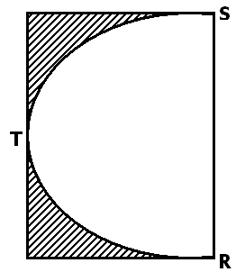 7

28. In a Mathematics exercise given to P. 7 pupils, the marks scored were recorded in the table below:

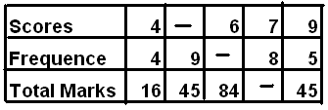

(a) Complete the table above.
(b) Find the number of pupils in the class.
29(a) Convert 2800gm into kilogrammes.
(b) The area of a square is 64cm². Calculate its perimeter.
30. Use the number line below to answer the questions that follow.
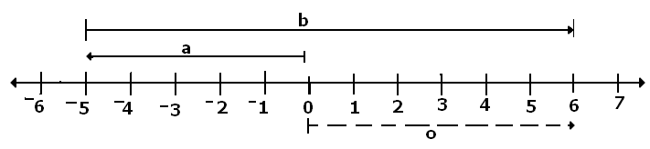

(a) What integers are shown by the arrow:

(i) a: (ii) b: (iii) o:
(b) Write the mathematical statement shown on the number line.
31. The graph below shows the number of absentees in a class of 80 pupils in a particular week in Kasoma Primary School.
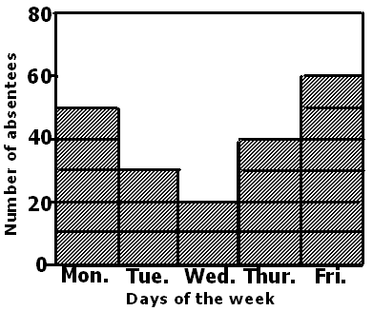

(a) How many pupils attended on Tuesday?
(b) On week of the week was the least attendance recorded?
(c) How many children attended school on Monday and Thursday?
32. The time-table below shows the arrival time and the departure time of the Pioneer Bus travelling between City Square and Entebbe.

Stages | Arrival | Departure
Kampala |  | 0845 hrs
Najanankumbi | 0900 hrs | 0905 hrs
Zana | 0915 hrs | 0920 hrs
Kajansi | 0934 hrs | 0939 hrs
Kisubi | 0954 hrs | 1000 hrs
Entebbe | 1015 hrs

(a) How long did the bus take to travel from Kampala to Zana?
(b) For how long did the bus stay at Kajansi?
(c) At what time did the bus leave Kisubi?
(d) How long did the bus take to travel from Kampala to Entebbe?
END
ITEM SIX
SECTION A:
1.Add: 256 + 122  2. What is the value of 6 DFin 21648?  3. Workout: 3 ¼ - 1 ½  4. Find the next number in the sequence  1, 2, 6, 15, 31, ___________, ___________  9. Given that n (A) = 24, n (A – B) = 6 and n (A u B) 32. Find n(B)  10. Magezi sold his bull at 760,000/- and realized 5% loss. How much did he buy it?  11. Find the size of angle P in the figure below.  40⁰2P  16. The average of y, 3y, 7y, 4y and 0 is 6. Find the value of y.  17. Solve the equation 5P – 8 = 42  6 | 5. A meeting lasting for 2 ¾ hours started at 9:40am. At what time did it end?  6. Simplify -9 - -6  7. Express 250ml as litres.  8. Subtract 3y – 8 from 8y – 18  12. A wire 5m long is to be cut into pieces. How many 25cm pieces can be got from it?  13. Divide 1212 by 4  14. A kilogram of sugar cost 2500/-. Find the cost of 750g of sugar.  15. Write 30304 in words.  18. In a class of 120pupils, the ratio of boys to girls is 7:3. How many girls are in the class?  19. A car travels at a speed of 20km/ hr covering a distance of 80km. how long does it take?  20. Using a pair of compasses, a ruler and a pencil only, construct an angle of 120⁰.

SECTION B
21a) Expand 3647 using powers of 10.  21b) Round off 967 to the nearest tens.  c) A school was started in MCMXC. In which year in Hindu Arabic numerals was the school star  22. In a class of 35pupils, 10 eat peas (P) 7 eat both peas and beans (B) while n eat beans only and 5 do not like any of the two food stuffs.  a) Represent the above information on the Venn diagram below.  n = (£) = 35  n(P) = 10 n(B)  b)Find the value of n  c) How many pupils eat beans?  25. In a school of 1500pupils, 40% of them are boys and the rest are girls.  a) Find the number of boys in the school.  b) If each girl contributed 200/- to buy a cake for one of the friends for a birthday celebration, how much was collected?  27) Two bells ring at intervals of 30minutes and 40 minutes respectively for lower and upper primary of a certain school.  a) After every how many hours will the bells ring together?  b) If the bells ring together at 9:30am, when will they ting together again?  28. Find the size of the unknown angles in the diagram below.  a)  2P 3P  28b) Express 15m/sec as km/hr  c) How many hours are there from 5.20pm up to 2:20am?  30.The diagram below is of a rectangle PQRS  (2p = 2)cm  R S  (P -2)cm  P Q  (P + 5)cm  a) Find the value of P.  b) Workout its area.  c) Find the length of its diagonal. | 23a) Solve 2x + 4 = 2 (mod 6)  3  b) Solve and write the solution set 16 > 4x > 4  24.a)Workout (7 x 15) – (7 x 8) using distribution property.  b) A tray of eggs carries 30 eggs. How many trays are needed to pack 960 eggs?  c) What base has been used?  5 3 1  -2 4 4  2 7 6  ______  26.a) Find the square root of 196.  26b)  7x  3x + 40⁰  29.The tank below is ¹/₃ full of water  a) How many litres of water are in the tank?  b) What will be the new level of water if 120litres are drawn from the tank?

31. Below is Omara’s shopping bill.
Item | quantity | Unit cost | Total cost
Sugar | 2kg | 2500/- each | Sh.______________
Pens | ____________dozen | 4500/- adozen | Sh. 3200
Nido milk | 3tins | _________each tin | Sh 22500
books | ___________dozen | Shs 6000 a dozen | Sh. 19500
 | Total expenditure
a) Compete the above shopping bill correctly.
b) If he was given 10% discount, how much did he pay for all the items?

32. The table below shows Mugabi’s monthly expenditure.
Item | Rent | Clothing | Food | Fees
percentage | 30% | 35% | x | 20%
a) Find the value of x.
b) Construct an accurate pie-chart to show Mugabi’s monthly expenditure (use radius of 3cm).

END

ITEM SEVEN
SECTION A:
1.Write ²/₃ in words  2. Solve 3 + C = 11.  3. Measure the line segment drawn below  4. An examination started at 8:30am and ended at 10:45am. How long did the examination last?  8. A basket contains 6 god eggs and 3 bad one. If a boy picked an egg at random. What is the probability that the egg picked is a bad one?  9. Show 5 backward steps on a number line below.  10. Name the solid shape shown below  -----------------------------------------------------------------  11. What pattern of numbers is shown below?  ● ●● ●●● ●●●●  ●● ●●● ●●●●  ●●● ●●●●  ●●●●  15. Workout the perimeter of the given shape below.  8m  B  3m  8m 3m  A  16. A man gets salary which is twice that of his wife. Calculate the man’s salary per month if their total salary for 2 months is 3millions shillings.  17. The exchange rate for 1 us dollar is 2,800 Uganda shillings. If John has 14 US dollars. How many Ugandan shillings will he get after exchanging? | 5. How do we tell that 1023 is divisible by 3  6. Given V = {a, e, I, o, u} Find n(V)  7. Today is Friday. What day of the week will it be after 133 days  12. Given set Q= {1,2,3}.Find the number of proper subsets in set Q.  13. 49 villages recovered relief food from the Uganda red cross. If each village received 760kg. How many tones of Posho did the red cross give?  14. What number was expanded as below?  (5 x 10⁵) + (4 x 10²) + (3 x 10³)  18. Solve ⁻3p – 2 > 7  19. Give one example of an infinite set.  20. Bwabye added 10 to a number and his result was less than 15. Find any possible value of the number if it is a counting number.
SECTION B
21a) Find the product of the value of 5 and value of 3 in 65,213. (3mark  b) Divide the value of 8 by the place value of 2 in the number 18425. (2marks)  22. Use the Venn diagram below to answer questions which follow.  F_{y} F₃₀  - Find the value of y. (2marks)  22b Workout the LCM of y and 30. (2marks)  c)Find the GCF of F_{y} and F₃₀(1marks)  24. In the space below construct five parallel lines to line  PQ (5marks)  P_________________________________Q  25. The time table below is for a P.4 class in Nakapiti part SDA school. Study it and answer questions which follow  a) How many hours do CAPE lessons take in the time table? (2marks)  b) How many double lessons appear on the time table above? (1mark)  c) On which days of the week is there no CAPE lesson taught? (1mark)  d) Which subjects have more lessons on the time table? (1mark)  26. Ochwo had 3times as many goats as Owere. When Ochwo sold 6 of his goats, he was left with 3 goats.  a)How many goats did Ochwo have?(3marks)  b) How many more goats did Ochwo have than Owere?(2marks)  27. In a class of 90pupils, 60 like hockey (H), 50 like tennis (T) m pupils like both hockey and tennis. 20 like neither of the games.  a) Draw a Venn diagram to show the above information.(3marks)  27.b) Find the value of m. (2marks) | 23. Show ⁻3 - ⁺6 on a number line and find its solution. (3marks)  23b) A rat is 2m below ground level and a monkey is 6m above ground level. How far apart are these animals solution? (2marks)  28a) Workout 45 x 3 ÷ 9 + 78 (3marks)  b) Simplify (16 + 5) x 6 (2marks)  29. A father distributed his salary among his wife, son, and daughter in the ratio 1:2:3 respectively. If his salary is 480,000/-?  a)How much did each get? (4marks)  b) Who got the biggest share of the salary? (1 marks)
   | 8:30  9:10 | 9:10  9:40 | 9:40  10:30 | 10:30  11:00 | 11:00  11:40 | 11:40  12:20 | 12:20  1:00
  Mon | MTC | ENG | SCIE | B | SST | CAPE | CAPE
  Tue | CAPE II | CAPE II | MTC | R | SCIE | SST | ENG
  Wed | SCIE | MTC | MTC | E | ENG | ENG | SST
  Thurs. | ENG | SST | SCIE | A | MTC | CAPE III | CAPE
  Fri | SST | CAPE II | CAPE II | K | MTC | ENG | SCIE
30. Fill in the blank spaces in the table below (5marks)

Buying price | Selling price | profit | Loss
Sh 4000 | Sh 3800 |  | _______
Sh 6000 | ___________ | Sh 1200
Sh 5240 | Sh 4480 | ________ | Sh 760
Sh 32500 | Sh 33000 | Sh________
________ | Sh 95550 |  | Sh 6300

31. Calculate the area of the figure below.(5marks)
(x + 7)cm

(x + 3)cm

(2x + 6)cm

32. The graph below shows the cost of groundnuts in kg. Study it and answer the questions that follow.

Number of kilograms
a)What is the cost of 1kg of groundnuts?

b) What is the cost of 7kg of groundnuts?
c)How many kg can I buy with sh 24000?

END

ITEM EIGHT

SECTION A

1. Work out: 7– 5
9 9
2. Write XIX in Hindu Arabic numerals.
3. Solve the equation: 2 y² = 24
3
4. Round off 29.561 to the nearest whole number.
5. Find the next number in the sequence: 2, 3, 6, 11, 18, ______
6. Write 12025g in kilograms.
7. Given that 10011_{two} = 23_{x}. Find the value of x.
8. What percentage of the figure is unshaded?
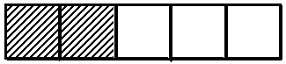

9. Simplify: ¯2 – ¯7
10. A stretch of a road is 2.5 km long. Trees are planted at a distance of 10m from each other. Find the number of trees planted.
11. Find the median of 5, 2, 0, 3, 4
12. Find the value of 2(a – b) if a = 5 and b = ¯3.
13. A PIASCY seminar ended at 9.10 a.m. At what time did it start if it took 55 minutes?

14. Using a pair of compasses, a ruler and pencil only, bisect the given angle below.
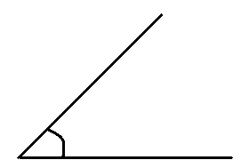

15. Divide: 24 ÷ 1.5
16. Find the area of the semicircle below. (Take π = 22)
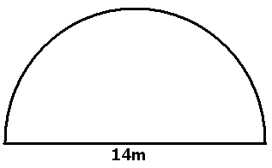 7

17. Work out: 10⁵ ÷ 10².
18. Find the size of angle n in the figure below.
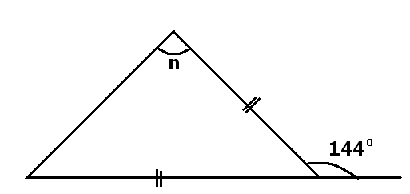

19. The average weight of 6 boys is 40Kg. Two boys weighing 40Kg and 20Kg leave the group. Find the average weight of the remaining four boys.

20. Describe the shaded region in the Venn diagram below.
ℰ
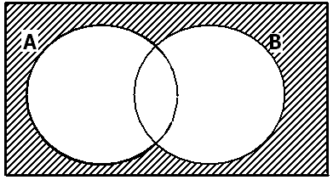

SECTION B

21 Find the area of the rectangle below.
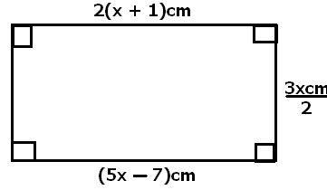

22. In a class of 56 pupils, 30 pupils eat matooke (M), X pupils eat potatoes (P) only, 4 pupils eat both matooke and potatoes while 2 pupils eat neither of the two types of food.
(a) Complete the Venn diagram given below using the information above.

ℰ = 56 (b) Find the value of X.

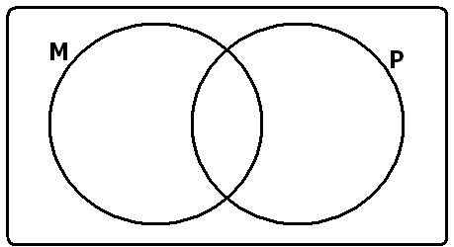

- How many pupils do not eat potatoes?

23. Given that m = (2n + 30⁰)

(a) Calculate the value of n in the figure below.
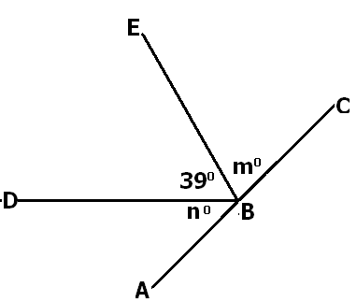

(b) Find the size of angle y in the figure below.
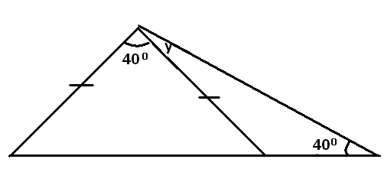

24. The diagram below shows a running track. Use it to answer the questions that follow.

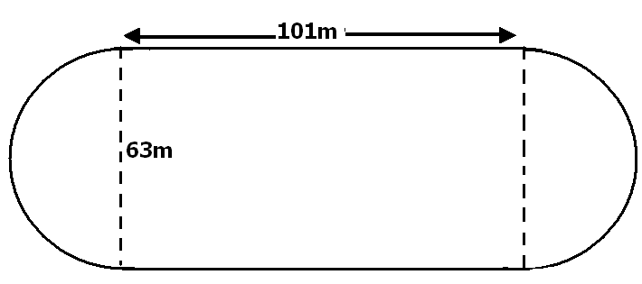

(a) find the perimeter of the track. (Take π = 22)
(b) How many laps should an athlete run around the track to cover a distance of 4.8 km?
25. Ssali drives at 120 km per hour and Ssegawa at 100 km per hour. If they leave town A at the same time to go to town B 360 km away, how far will Ssegawa be from town B when ssali arrives there?

26(a) Using a pair of compasses, ruler and a pencil only, construct a rhombus ABCD such that AC=8cm and BD=6cm.
(b) Find the perimeter of the above figure.

27(a) Solve: 8x – 1 = 2x + 5
5 3

(b) Musoke is 10 years younger than Ali. In 5 years’ time, Ali will be twice as old as Musoke. How old is Musoke now?
28. Pondi went with sh.50,000 and bought the following:
3 kg of sugar at sh.3,400 per kg.
4 sachets of salt for sh.2,000.
2 kg. of rice at sh.4,500 per kg.
1½ kg. of meat at sh.10,000 per kg.

(a) How much money did he spend altogether?
(b) If he was given a discount of 10%, what was his balance?
29(a) Given that y = 2x – 5, complete the table below.
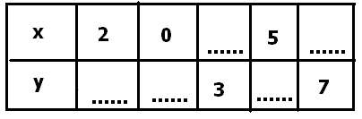

30. The table below shows the number of pupils in each class in a school.
P. 1 30
P. 2 36
P. 3 30
P. 4 24

Draw a pie chart of radius 4cm to represent the above information.

31. The digits 3, 4, 5 are arranged in a random order to form three - digit numbers. No
digit is repeated in any number formed.

(a) Write down the possibility space for the numbers formed.

(b) Determine the probability that the number formed is odd.

32. Of the three church bells, one rings at an interval of nine minutes, the second at an interval of twelve minutes and the third at an interval of fifteen minutes. If they ring together at 9:30 a.m., when will they next ring together again?

END

ITEM NINE
SECTION A (40 marks)
(Question 1 to 20carry two marks each)

- Add: 4 + 17
- Write in figures: Sixty thousand, twenty.
- Simplify: 2y – 4x + y
- Given that set M = { 2, 4, 6 }, find the number of subsets in set M.
- Work out: 4 - ⁻ 2
- Find the next number in the sequence.
1, 3, 6, 10, ____
- How many lines of folding symmetry has the figure below?

- The cost of 3 pens is Sh. 2400. What is the cost of 2 similar pens?
- Change 4kg to g.
- Work out: $\frac{1}{3}$ + $\frac{1}{2}$
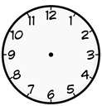
- What afternoon time is shown on the clock face below?

- Using a protractor, measure the angle ACB below in degrees.

A

B
C

- Workout: 1101_{two} + 111_{two}
- Given that a = 2, b = 3 and c = 4, find the value of b(a+c)
- Find the median of the numbers: 8, 10, 4, 1, 6 and 9.
- Write XCIX in Hindu Arabic numerals.
- Find the value of x in the diagram below.

3xº 2xº
- Work out: 2 – 6 = ____ (mod 7)
- Write 0.08 as a fraction in its simplest form.
- Describe the shaded region.

A B

SECTION B (60 marks)
(Marks for each question are indicated in the brackets.)

- (a) What number has been expanded to give;
- X 10 x 10 x 10) + (5 x 10) + (7 x 10 x 10) ? (2 marks)

(b) Represent 3 2 0 1 on the abacus below. (2marks)

- Study the figure below and use it to answer the questions that follow.
- Find the value of;(2 marks each)
F_{y} F_{w} (i) y
3₁

2₁
5₁
2₂

3₂

(ii) w

(b) Workout the LCM of y and w. (2 marks)

- In a class of 32 pupils, $\frac{3}{8}$ are girls,
- Find the fraction of boys. (1 mark)
- How many girls are in the class? (2 marks)
- How many more boys than girls are in the class? (3 marks)

- Study the Venn diagram below and answer the questions that follow.
- Workout the value of y (2 marks)
n(Ԑ) = 50
n(V)
n(X)
25 - y
20 + 2y
3

(b) Find: (2 marks each)

(i) n(V)
(ii) n(V – X)

- (a) Solve: 3(t – 2) = 6 (3 marks)
(b) Find the total distance around the figure. (2 marks)
5x cm

3x cm

4x cm

- A man had three children, Juliet, Brenda and Tom. He shared 48 acres of land among them in the ratio of 2 : 3 : 1 respectively. Calculate the acres of land each child got.
- (a) Construct a triangle ABC using a pair of compasses and a ruler only.
Given that AB = 6cm, A = 45º and B = 60º (4 marks)

(b) Measure line; (i) AC (1 mark)

- Study the number line below and answer the questions that follow.

e

f

-7
-6
-5
-4
-3
+8
-2
-1
0
+1
+2
+3
+4
+5
+6
+7

g

- Name the integers represented by the arrows; (3 marks)
- e = ____________________________
- f = ____________________________
- g = ____________________________
- Write down a Mathematical statement for the number line above. (2 marks)
- Ssonko scored the following marks in different subjects:
60, 54, 73, 80 and 83
- What was Ssonko’s median mark? (2 marks)

- Find the range of his marks. (1 mark)
- Workout his mean mark. (2 marks)

- (a) Add m cm (b) Subtract: l ml (2 marks each)
4 60 7 800
+ 3 55 - 3 850

- Josbel and her daughter travelled from Kampala to Nairobi by bus.
She paid K.Sh 1500 and her daughter paid K.Sh 760.
Given that the exchange rate was K.Sh 1 = Ug. Sh 34.
- Find the bus fare in Uganda shillings that each paid. (4 marks)

- If JosbelhadUg Sh. 102,000 at the beginning of the journey. What was her balance in Uganda shillings after paying the bus fare for both? (2 marks)

- A man drove from Kampala to Kasese a distance of 840 km in 6 hrs.
- Calculate his speed. (2 marks)

- Change 4 $\frac{1}{2}$ hrs to minutes. (2 marks)

END

ITEM TEN
Sention A
1.Add 13 to 320
2. Write 104,104 in words.
3. Find the GCF OF 15 and 35.
4. Simplify 2y – 4q –y ⁺3q
- 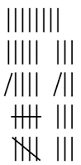What number has been represented by the tallies below?

6. Find the volume of the figure below. Take π = ²²/₇

.
_{7cm}

_{20cm}

7. Simplify ⁻1 -⁻4 - 2.

8. Workout ¹/₅ ÷ ⁴/₃

9. Workout 7272 ÷ 3.
10. Given that P = {1, 3, 5, 7, 9., 11, 13)
Q = {2, 3, 5, 7, 11) Find n(P n Q)

11. Express 1 ¹/₃hrs as minutes.
12. Given that a = 4, b = 3 and C = -3. Find the value of 2(a + b + c)
13. The table below show the marks scored in weekly test by P.6 pupils at lee-lee primary school
marks | 70 | 85 | 90 | 50
No of pupils | 3 | 1 | 2 | 4
Find the median mark.

14. Express 2kg as a percentage of 400grams
15. Measure the length of the line PR

P R

16. Find the value of r

r

17. Find the square root of ⁹/₃₆
18. Round off 599 to two decimal places.
19. Find the next number in the sequence below.
22, 15, 9, 4, 0, ________
20.P and Q are sets, draw a Venn diagram to represent the relationship between P n Q
SECTION B
21. The diagram below shows P.7 pupils of Mudo primary school who like math (M) and English (E)

n(m) E (a) If 30 pupils like math’s only, find the value of r. (2mrks)

b) How many pupils like math? (1mrk)

(c) How many pupils are in the class? (1mrk)
r-20 r r-10

22a. Find the value of P (2mrks)
( 2p – 3)cm

(p-2)cm

(p)cm
(p + 2)cm

(b) Find the area of the shaded part (3mrks)

23. David had 40 oranges. He gave ³/₅ of the oranges to his friends Edison and Samson. Edison got ¹/₃ of the orange given to them; Samson got ¾ of what Edison left. The remaining oranges given to them were bad.
a)How many oranges did Edison got?
(b) How many oranges did Samson get? (2mrks each)
c) What fraction of orange given to them was bad?

25. A bus left town A at 8:40am and arrived town B at 11:40am travelling at a speed of 50km in one hour, it then continued for two hours to town C At a speed of 80km/hr
a) Find the distance between town A and town C. (3mrks)
b) Calculate the average speed of the bus for the whole journey. (2mrks)

25. In a class, the ratio of boys to girls is 8: 3. There are 30more boys than girls.
a) Find the total number of pupils in the class? (3mrks)
b) What is the number of girls in the class? (2mrks)

26. The sum of three consecutive odd numbers is 33. If the middle number is K. find the range of the number. (5mrks)

27. The pie-chart below shows mock results of Abifa primary school 2018.

Grade 1 grade 2

120⁰ 110⁰

X
Grade 3
a) Find the value of x

(b) If the school had 36 pupils, how many passed in 2nd grade?

28a) Solve 3(4x – 4) – 2(3+ 3x ) = 6 (3mrks)
(b) Simplify (4p – 7)-(2p – 4) (2mrks)

29. A businessman sold a shirt to Adam at sh 63000 making a loss of 10%. Adam sold it to Andrew at a profit of 15%
a) Calculate the amount of money the businessman paid? (3mrks)

b) For how much money did Andrew pay for the shirt (2mrks)
30. The volume of the water in the tank below is 1540cm³
a) Find the height of water. (Use π = ²²/₇) (2mrks)

14cm

h1 100cm

b) How much water is needed to fill the tank? (3mrks)

31. Using a pair of compasses, a ruler, a pencil only, construct a triangle ABC in which B = 7cm, BC = 5cm angle ABC = 60^{O}. (4mrks)

b) Measure the length AC (1mrk)

AC = __

32. Joshua bought a rectangular door that measured 100cm by 70cm and he was to use it to cut circular chairs of radius 7cm.
a) How many chairs did he make? (2mrks)
b) Calculate the area of the door which was not used (4mrks)

END

ITEM ELEVEN
SECTION A
1. Workout: 3 0 7
+ 5 2

2. Write 97 in Hindu Arabic numerals.

3. Solve 2P² = 24
3
4. Round off 29.561 to the nearest ones.

5. Express 12056kg in tones.

6. Simplify: ⁻7 - ⁻2

7. Find the next number in the sequence.
1, 3, 6, 11, 18, 29, ____

8. What percentage of the figure is unshaded?

9. Find the median if 5, 2, 0, 3 and 4

10. Find the value of 2(a-b), if a = 5 and b = ⁻3

11. A maths workshop ended at 9:10am. At what time did it start if it took 55 minutes.
12. Workout: 24 ÷ 1.5
13. Using a pair of compasses, a ruler and a pencil only, bisect the given angle below.

14. Subtract 3a – 2b from 5a + 3b

15. Simplify: 10⁵ ÷ 10²

16. Find the value of n in degrees.
n
n

110⁰

17. Express 0.666…….. as a fraction.

18. The average weight of 6 men is 40kg. Two men weighing 40kg and 20kg leave the group. Find the average weight of the remaining 4 men.

19. Shade (A-B) complement.

B A

20. The interior angle of a regular polygon is 120. How many sides does the polygon have?

SECTION B (60 MARKS)
21. a) In a class, the ratio of boys to girls is 3:5, if there are 24 boys
in the class, how many girls are there?
b) How many more girls than boys are in the class?

22. Find the area of the figure below.
2(x + 1)cm

(3x)cm
2

(5x – 7)cm

23a) Simplify 3(2x – y ) – (x – 3y)

b) Given that n =12, w = 8 and P = 9. Workout
np + 4w
2p

24. A driver travelled for 3 hour 45 minutes at an average speed of 64km/hr. How long did it take on the return journey at an average speed of 80km/hr?
25. Musoke is 10 years younger than Ali. In 5 years time, Ali will be twice as old as Musoke. How old is Musoke now?
26. In a class of 56 pupils, 30 pupils eat matooke (M), X pupils eat potatoes (P) only, 4 pupils eat both matooke and potatoes while 2 pupils eat neither of the two types of food.
a) Complete the Venn diagram given below using the information above.

_____ 4 _____
M = ___ P = ___

_____

b) Find the value of x.
c) How many pupils do not eat potatoes?
27. a) Joy went with sh. 21,000 and bought the following;
- 3kg of sugar at sh. 2400 each
- 4 packets of salt for sh. 1000.
- 2kg of rice at sh. 2400 per kg.
- 1 ½ kg of meat at sh. 5000per kg
How much change did she get after paying for all the items?

28. a) Using a pair of compasses, a ruler and a pencil, construct a
rhombus ABCD in which each side is 5cm and angle ABC = 60⁰.

b) Measure the length of diagonal BD._____

29. The digits 3, 4 and 5 are used to form three digit numbers.
a) Write down the possibility space for the numbers formed.
b) Find the probability that the number formed is odd.

30. a) Given that;
Y = 2x – 5, complete the table
X | 2 | 0 |  | 5
Y |  |  | 3 |  | 7

b) Using the above coordinates, plot them on the graph below
and join the coordinate points.

 |  |  |  |  |  | 8
 |  |  |  |  |  | 7
 |  |  |  |  |  | 6
 |  |  |  |  |  | 5
 |  |  |  |  |  | 4
 |  |  |  |  |  | 3
 |  |  |  |  |  | 2
 |  |  |  |  |  | 1
-6 | -5 | -4 | -3 | -2 | -1 | 0 | 1 | 2 | 3 | 4 | 5 | 6 | 7
 |  |  |  |  |  | -1
 |  |  |  |  |  | -2
 |  |  |  |  |  | -3
 |  |  |  |  |  | -4
 |  |  |  |  |  | -5
 |  |  |  |  |  | -6
 |  |  |  |  |  | -7

31. The table below shows the number of pupils in each class in a school.
P1 | P2 | P3 | P4
30 | 36 | 30 | 24

Draw a pie chart of radius 4cm to represent the above information.

31a) The head teacher of our school got a personal loan of 2400, 000/- from centenary Bank at a rate of 20% per annum. Calculate the simple interest he is supposed to pay after nine months.

b) John and Martha shared 4 apples in a ratio of 3:2 respectively. How many apples did each get?

END

ITEM TWELVE
SECTION A (40 MARKS)
1. Add: 33+3

2. Simplify: 3p + 2p

3. Find the value of 2 in 3.002

4. What is the place value of 8 in 784903?

5. Write in standard form: 348

6. Find the next number in the sequence
18, 15, 12, 9, ___________

7. In the Venn diagram below, shade the region representing the set Y complement of set X
X Y

8. Subtract: $\frac{5}{6}$ - $\frac{5}{12}$

9. Convert 40 cm to metres

10. Awinjo bought a hen for sh. 10,000 and sold it to Nyapendi making a loss of sh. 1200. How much money did Nyapendi pay for the hen?

11. Workout: 1 – 4 = _____________________ (finite 5)

12. The travel graph below shows how Kayondo travelled from school back home.
Calculate Kayondo’s average speed for the entire journey
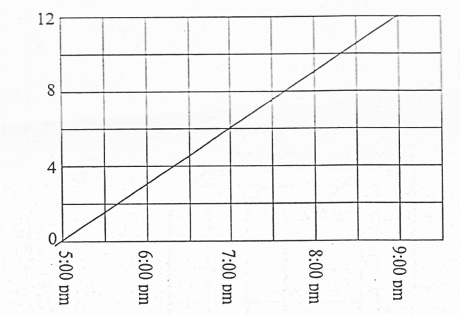

13. Divide: 201 ÷ 3

14. Workout: Weeks Days
5 2
- 2 5

15. Find the square root of : $\frac{36}{144}$

16. Find the total distance around the figure below.
A

5 cm

C
B
4 cm

17. Given that: A = 0, 1, 2, 3, 4 B = 2, 3,, 5, 7, 11
Find n (A - B)

18. In a church service attended by 200 people, the ratio of adults to children was 3:7 respectively. How many children attended the church service?

19. Express 10m/s to km/hr

20. By counting squares, find the volume of the cuboid below in cubic units.
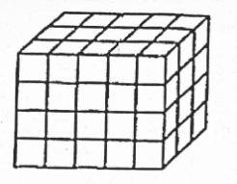

SECTION B
21. a) Write 7411 in expanded form (1 mk)

b) Round off 9486 to the nearest thousands (2mks)
c) Write CXC in words (2mks)

22. a) With the help of a ruler, sharp pencil and a pair of compasses only, construct a triangle LMN in which LM = 7cm, <MLN = 90⁰ and
<LMN = 30⁰

b) Measure i) LN = _____________________ ii) MN = _______________
(1 mk)
23. The table below shows the marks scored by P6 pupils in a mathematics test.
Marks scored | 80 | 70 | 60 | 90
Number of pupils | 3 | 1 | 4 | 2

a) How many pupils did the test? (1 mk)

b) What was the modal mark? (1 mk)

c) Find the median mark (1 mk)

d) Calculate the average mark scored by the pupils (2 mks)

24. a) Solve: 2c - 8 = 0 (2 mks)

b) Given that a = 3 and b = -4, Find the value of 2a – 2b. (2 mks)

c) Subtract: (2x - 3y) from (4x – 9y) (2 mks)

25. In the triangle below, < ABC = 50⁰
y + 20⁰
2y

a) Find the value of y (2 mks)

b) Find the size of angle BAC (2 mks)

26. a) Workout : 3.6 x 0.72 (2 mks)
2.4
b) A man sold $\frac{2}{3}$ of his land and gave out $\frac{1}{3}$ of the remainder. What fraction remained?
27. a) How many minutes are in 2 hours? (2 mks)

b) A birthday party which started at 10:50pm. How long did the party last?
c) A car covered 96km in 1 ½ hours. Calculate its average speed in km/hr.
28. In a class of 120 pupils, 40% are boys and the rest are girls.
a) What is the percentage of girls? (2 mks)

29. In a school with 23 teachers, 11 teach mathematics (M), 13 teach science (S), ‘X’ teach both subjects while 8 teachers teach other subjects.
a) Represent the above information on the Venn diagram below (3mks)

n(M) =11 n(S) =13

_______ X _____

____

b) How many teachers teach both mathematics and Science?
30. Atono sells items in her shop as follows;
1kg of rice at sh. 3000
1 kg of sugar at sh. 2400
1 litre of cooking oil at sh. 4800
a) How much money does Atono get when she sells 1 litre of oil and
½ kg of sugar? (2mks)

b) If a customer remained with 10,000 shillings after buying 1 ½ kg of rice and a litre of cooking oil from
Atono’s shop, how much did he have first?
c) If Atono buys a 50kg bag of sugar for sh. 100,000, calculate her profit on selling 1kg of sugar.
31. Mwiine is 7 years older than Lubanga. Their total age is 23 years.
a) How old is Lubanga now? (2mks)

b) Find Mwiine’s age now? (1mk)

c) How old will Lubanga be in ten year’s time from now? (1mk)

32. Study the pie chart below and use it to answer questions that follow.
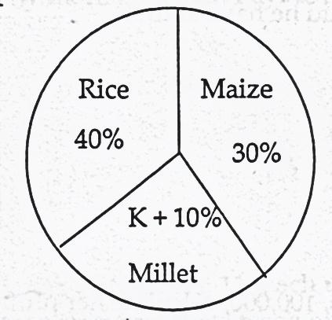

a) Find the value of k in degrees (2mks)
b) If the sector for Rice represents 200 bags, how many more bags of rice are there than maize? c) Express the sector for millet in degrees (2mks)

END

ITEM THIRTEEN
SECTION A
- Add: 0.41 + 2.
- Express CXLX IN Hindu Arabic.
- Round off 49.96 to the nearest tenths.
- Increase sh.12000 in the ratio of 5.3.
- Given that a = 5 and b = 0.Find the value of 2a +5.
- Find the value of y.
3y
120⁰

- Simplify 5y-6m-3m+7y.
- In the space below construct angle of 150⁰ with the help of a ruler, pencil and a pair of compasses only.
- Find the sum of the next two numbers in the sequence.
6, 10, 15, ______, ______
10. Write seven hundred thousand, thirty two in digits.
11. Describe the shaded part.
A B

12. Multiply: 1001_{two} by 11_{two}.

13. Simplify 1 + 1 -1
3 5 4
14. Find the complement of (30-2n)⁰.
15. Work out -3 -⁺5.
16. Find the length of the diagonal AC.
C
D
5cm

12cm
B
A

17. In a class, the ratio of girls to boys is 3:2. Find the number of pupils in the class if there are 24 girls.
18. Find the area of the figure below.
4cm
6cm
11cm

19. Work out: 4 ÷ 8.
7 21
20. In a class, 3 of the pupils are boys. If there are 250pupils in the class, find the number of boys.
5
SECTION B
21. At a class party of 41 pupils, 18 drank Mirinda (M), 19 drank Fanta (F), 9 drank both Mirinda and Fanta, while 6 did not drink any of the two sodas.
a). Complete the diagram using the above information.(2mks)
n(€) =41
M
F
g
________
________

6

b). Find the value of g. (2mks)
c). Find the number of pupils who drank one type of soda.(2mks)
22. Solve: 3m + 6 = 21-2m.(3mks)
b). Solve and write the solution set 3(1-x) < 15. (3mks)
23. Tap A fills a tank of 6 minutes and tap B can fill the same tank in 3 minutes.
a). How long will the two taps take to fill the same tank if opened at once?(3mks)
b). What fraction of the tank will the two taps fill in 1 minute?(1mk)

24. Kamara went to the market and bought the following items shown in the table below.
ITEM | QUANTITY | PRICE | AMOUNT
Mangoes | 15 | Sh.300 per mango | Sh. _____________
Beans | ______kg | Sh.6000per kg | Sh. 15,000
Cooking oil | ½ litre | Sh. ________per litre | Sh.2000
Sugar | 1 ½ kg | Sh. 3000 per kg | Sh. _____________
 |  | Total | Sh.______________

a). Complete the table above. (5mks)
b). If Kamara went to the market with sh.30,000, how much did he remain with?
25a). Given that the mean of 3, n+5, 1,n+3 and 5 is 5. Find the value of n.
b). The average weight of 5 boys is 48kg. When a sixth boy joins them, the average becomes 45kg. What is the weight of the sixth boy?(3mks)
26. The pie-chart below shows how a farmer divided his land. C is for crops, G for grazing, T for Trees and R for reverse. The land available is 720 hectares,
X⁰
2X⁰
R
G
T
3x⁰
3x
C

a). How many hectares are left for grazing? (2mks)
b). If a farmer pays sh.5000per hectare per year, how much will he pay for land reserved for crops?
27a). Work out: 0.04 + 0.4
0.04
b). Hilda is standing in a straight line in the 7thposition from either side of the line. How many people are in the line?
28. Nabbosa is 18 years older than her sister. in how many years will Nabbosa be twice as old as her sister the sister is 8 years old now?
29. Mary used $\frac{1}{3}$ of her land for grazing and$\frac{2}{5}$ of the remainder for
cultivation. She had 20 acres still left.
a). What fraction of the land was used for cultivation?(2mks)
b). How big was Mary’s land in acres? (2mks)
30. Without using a protractor, construct a triangle PQR such that PQ= 5cm. PQR = 1200 and QPR= 30⁰. Drop a parpenderdicular from R to meet PQ at point P. (5mks)
a). Measure PR (1mk)
b). Calculate the area of the figure. (2mks)
31. Study the number line and answer the following questions.
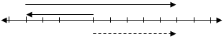
a). Write the integers for (1mk@)
P = __________________
Q =__________________
R = _________________
b). Write down the mathematical statement shown.
32. (a) 3 men can do a piece of work in 6 days, How long will 9 men take to do the same piece of work, working at the same rate?

b) How many days would 3men take than 9 men in doing the same work?

END

ITEM FOURTEEN
SECTION A:
- Add: 46 to 51
- Write “fifty-eight thousand, fifty-eight” in figures.
- Find the difference of the second and seventh prime numbers.
- Simplify:
- Draw a Venn diagram to show that all cows(C) are animals.
- Work out the value of 2P in the figure below.
P

110⁰

- Express 22.5km in cm.
- A motorist drove from 9:50a.m for 3 hours 5 minutes from Kampala to Iganga. At what time in 24 hour clock system did he reach Iganga?
- The average mass of 8 girls is 45kg. What is their total mass?
- Solve: 3 – 2y = ⁻13.
- The temperature of a studio was 12⁰C. It dropped by 5⁰C. What was is new temperature?
- Using a ruler, a sharp pencil and a pair of compasses only, construct an angle of 135⁰.
- By selling a shirt for sh.20, 000, a trader made a loss of sh.5000. What was the percentage loss made?
- Calculate the capacity of the water tank shown below in litres.
70m

14m

- Express 34.698 in standard form.
- Write down the mathematical sentence represented on the number line below.
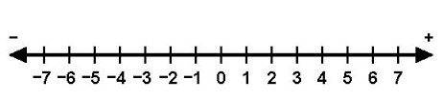

- Subtract 322_{five} from 401_{five}
- Find the next term in this sequence. 1, 4, 9, 16, 25, ___
- Given that P =-6, y = 4 and K = 0, find the value of: y^{k} + P
- In the Venn diagram below, shade the complement of n(B C)
ع=
B
C

SECTION B
- In a group of 40 people, all like meat (M), 25 like both meat and fish (F), 16 like both meat and chicken (C), W like all the three dishes and 5 like neither of those dishes.
- Complete the Venn diagram below.
n(ع)
n(C
n(F)

……
……
w

……

- How many people like only two dishes?
- Amooti, Akiiki and Ateenyi shared dollars in the ratio of: respectively.
- If Amooti received four more dollars than Akiiki, how many dollars did they share altogether?
- What percentage of the whole share did Ateenyi get?
- Study the figure below and answer questions that follow.

- Work out its actual length and perimeter.
- Calculate its actual area.
- Ojobire is 20 years older than Obiina. In four years’ time, Obiina will be half as old as Ojobire.
- How old is each now?
- What was Ojabire’s age six years ago?
- Below is a cuboid (K) and a big box (M). Musobya packs milk powder in cuboids and packs them in the big box for export to Southern Sudan.
7cm
(K)
42cm
(M)
55cm
50cm
4cm
5cm

Calculate the space left empty after packing cuboids (K) into the big box(M)
- The table below shows how pupils got their marks in a certain weekly test. Study it carefully and answer questions about it.
Marks | 20 | W | 70 | 50
Number of pupils | 2 | 3 | 1 | 1
- Find the value of w if the man mark was forty.
- How many pupils in total scored above and below the median mark?
- A woman spent of her monthly income on clothes, of the remainder on rent and kept the rest.
- What fraction of her income did she keep?
- If she kept two hundred thousand shillings, how much is her monthly income?
- (a) Expand 6979 using powers of base ten.
(b) Find the product of the value of 8 and the place value of 6 in 87960.
- (a) Using a ruler, a sharp pencil and a pair of compasses only, construct a regular pentagon whose one side is 4.5cm.
(b) Show the lines of folding symmetry in the accurate diagram above.
- Otada bus travelling at 55km/hr took 4 hours to cover part of its journey. The rest of the journey which was a fifth of the covered journey was travelled in only 2 hours. What was the average speed of the bus over the whole journey?
- In the diagram below, line MN is parallel to PQ and PQN is an isosceles triangle. Use it to answer questions that follow
N
P
Q
7k
3k
M

- Find the value of K.
- Calculate the size of QNM.
- A woman went to capital shoppers and bought;
3kg of maize flour at sh. 4000 a kg.
4 litres of milk at sh. 1600 per half litre.
8 sweets at sh. 2000 for every 4 sweets.
- What was the total cost of all the items?
- If she went with 2 twenty thousand shilling notes and was given a discount of sh. 1500, how much was her change?

END

ITEM FIFTEEN
SECTION A:
- Write “230,406” in words.
- Express 49 in Roman numerals.
- Work out
- In the figure below, find the value of n.
n
(3n + 20⁰)
(3n + 20⁰)

- Express 43_{ten} in binary base.
- If set P = {1, 4, 5, 7, 8} How many subsets has set P?
- A fence is 4.5km long. What length is it in metres?
- The Venn diagram below represents a group of children who play either football (F) or volleyball (V). How many children play volley ball.
6
F
V
9
4

- Find the next number in the series 5, 5, 6, 8, 11, 15,____
- Simplify (4x – 2) -2(1 +3x)
- The mean age of 3 boys is 11 years. Two of the boys have 11 and 13 years. What is the age of the third boy?
- In the space below, with the help of a ruler and a pair of compasses, construct an angle of 45⁰.
- Given that a = 5, b = ⁻3, find the value of a – ab.
- Kamanya covered 300km in 2 ½ hours. Find his speed.
- Solve: - 4 = 15 x 2 + x
- Okurut deposited 160,000/= in a Stanbic bank at an interest rate of 10% per year. What interest will he get on his account after 2 ½ years?
- Solve: -3a + 7 < 1 and write the solution set.
- In the figure below is a Rhombus with diagonals AC = 12cm and DB =16cm. Find the length of one side of the Rhombus.
D
A
B
C

- The figure below is a tank full of water. How many litres of water are in the tank?
70cm
40cm

- Find the least number which can be divided by 10 or 12 of 15 without a remainder.
SECTION B
- (a) Solve 3y - ½ y =5
(b) A father is three times as old as his son. The difference between their ages is 30 years.
(i) How old is the son?
(ii) Find the father’s age.
- The frequency table below shows the weights of boys in a P.6 class at Atim Primary school. Study it carefully and answer the questions that follow.
Weight in kgs | 25 | 30 | 20 | 15 | 35
Number of boys | 2 | 1 | 3 | 4 | 5
- Find the number of boys in the class.
- What is their total weight ?
- What is the range of their weight?
- Calculate the mean weight per boy.

- Below is a rectangular plot of land.
(x +3)m
(2x +5)m
(5x – 7)m

Find the distance around the plot of land.
- (a) The price of a bag of sugar was increased from 50,000/= to
shs.72, 000/=. Find the percentage increase.
(b) Nafunga a shopkeeper bought a dress and later sold it at sh.49,500
making a loss of 10%. How much had she paid for the dress?
- Okulo went to the supermarket and made the following expenditure.
15 books at shs. 2000/= per book.
4 kg of meat at shs. 10,000/= a kg.
7 bars of soap at shs.3800/= a bar.
9 brooms at shs. 18,000/=.
What was his total bill?
- The figure below is an isosceles triangle PQR in which PQ = QR, PR = 4x and QRP= 20⁰ + 2x.
Q
4x
(20⁰ + 2x)

R
P

- Find the value of x.
- Calculate the size of angle PQR in degrees.
- Ssendi packs cylindrical tins whose height is 10cm and diameter is 5cm in a rectangular box (carton). If the carton measures 60cm long by 20cm wide by 30cm high.
- How many tins will be packed in the cartons?
- Find the space (in cm³) that will remain after the tins have been packed in the carton.(Take π 3.14)

- In a P.7 class of 55 pupils, 25 of them passed Maths (M), 35 of them passed English (E), 10 passed both subjects and 5 failed both subjects.
Complete the Venn diagram below.
E
M
N(ع) = 55

- Find the number of pupils who passed only one subject.
- If a child is picked at random to be a prefect, what is the probability that the one picked passed Maths only?
- (a) Using a pair of a compasses a sharp pencil and a ruler only, construct triangle ABC in which AB = 6.4cm CAB = 90⁰ and AC = 3.6cm.
- Measure BC.
- Measure CBA
- Below is a cylindrical piece of hollow wood. (π = 3 )
21cm
10cm
8cm

- Find the volume of material removed to drill the hollow.
- Find the volume of the wooden cylinder left.
- At a party, Ocom, Muleera and Kibanda contributed some money in a ratio 4:2:6 respectively. If Kibanda contributed shs. 48,000/=
- What was their total contribution?
- What was Ocom’s contribution?

- The travel graph below shows the journey of a motorist from town A through B to C and back to A.

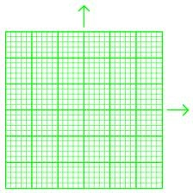
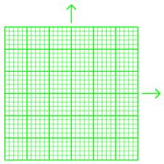
C
B
12:00 noon
DISTANCE IN KM
4:00p.m
3:00p.m
2:00p.m
1:00 p.m
10:00a.m
9:00a.m
11:00a.m
A
80
60
0
140
120
100
40
20

TIME IN HOURS

- What is the speed of the motorist from A to B?
- For how long did he rest at town C?
- Calculate the average speed of the motorist for the whole journey?

END

